**Project description**

The project is a personal website built with HTML5, CSS3, and ES6 modules (front-end only, no back-end).

It has three main pages:

* Home – introduction, photo, name, navigation bar.
* About – education, experiences, and skills.
* Footprints – an interactive world map with clickable pins that show photos from different places I have visited.

Goals:

* Showcase myself (background, skills, experiences).
* Present my travel“footprints”in a visual way.

**User Personas**

* Persona 1 – Recruiter (Alice, 37)

Demographics: Female, 37 years old, HR recruiter at a mid-size tech company.

Behavioral Traits: Busy, scans resumes every day, sometimes browses the websites to find interesting candidates.

Goal: Identify qualified candidates quickly, understand their background and projects without reading long documents.

Pain points: Overloaded with resumes; Doesn’t want to read long PDFs or complex layouts.

Motivations: Values efficiency, clarity, and professionalism. Motivated to find strong candidates who stand out.

Scenarios/User story: She opens the personal website from a resume link. She needs to find the basic information of the candidate from the About page within seconds and understand the candidates’ key experiences and skills.

* Persona 2 – Friend/Peer (Jason, 24)

Demographics: Male, 24 years old, graduate student in computer science, classmate of the site owner.

Behavioral Traits: Sociable, curious, likes to explore photos and stories, prefers interactive and visual content.

Goal: Stay connected with the friend, enjoy looking at travel photos and personal stories.

Pain points: Gets bored with text-heavy content; frustrated if navigation is confusing.

Motivations: Values friendship, shared experiences, and easy access to visual content. Motivated by curiosity and social connection.

Scenarios/User story: He wants to have more friends of the same program and learns more about his classmates. He opens the website and clicks on the footprint page, as he is curious about what the footprint page will display. He enjoys seeing the gallery of the travel photos of the site owner.

* Persona 3 – Professor (Dr. Lee, 50)

Demographics: Male, 50 years old, university professor.

Behavioral Traits: Time-constrained, prefers clear and structured information.

Goal: Track student’s progress.

Pain points: Dislikes messy layouts, hidden navigation, or unprofessional presentation.

Motivations: Values clarity and evidence of growth. Motivated by helping students succeed.

Scenarios/User story: Dr. Lee opens the student’s site before a meeting, clicks on the About page, and quickly reviews past work and skills.

**Design mockups**

-- created by Figma

First Page:

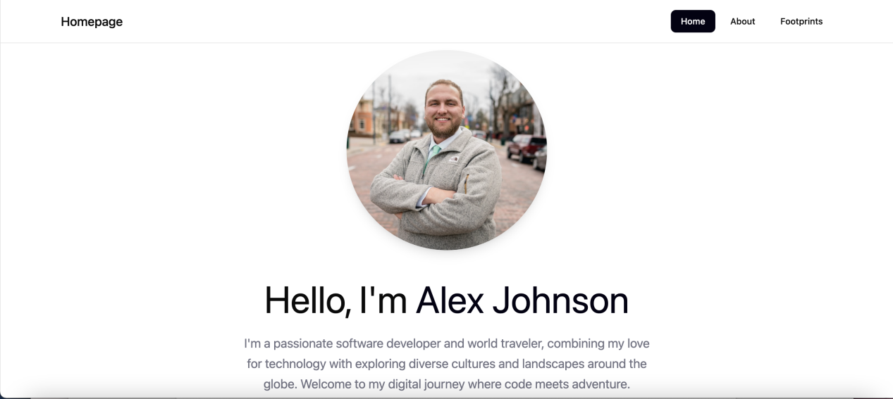

Second Page:

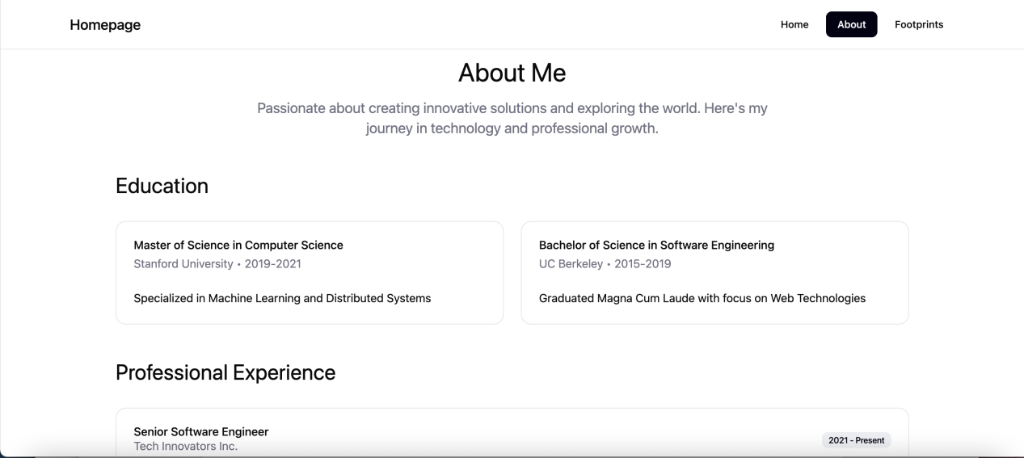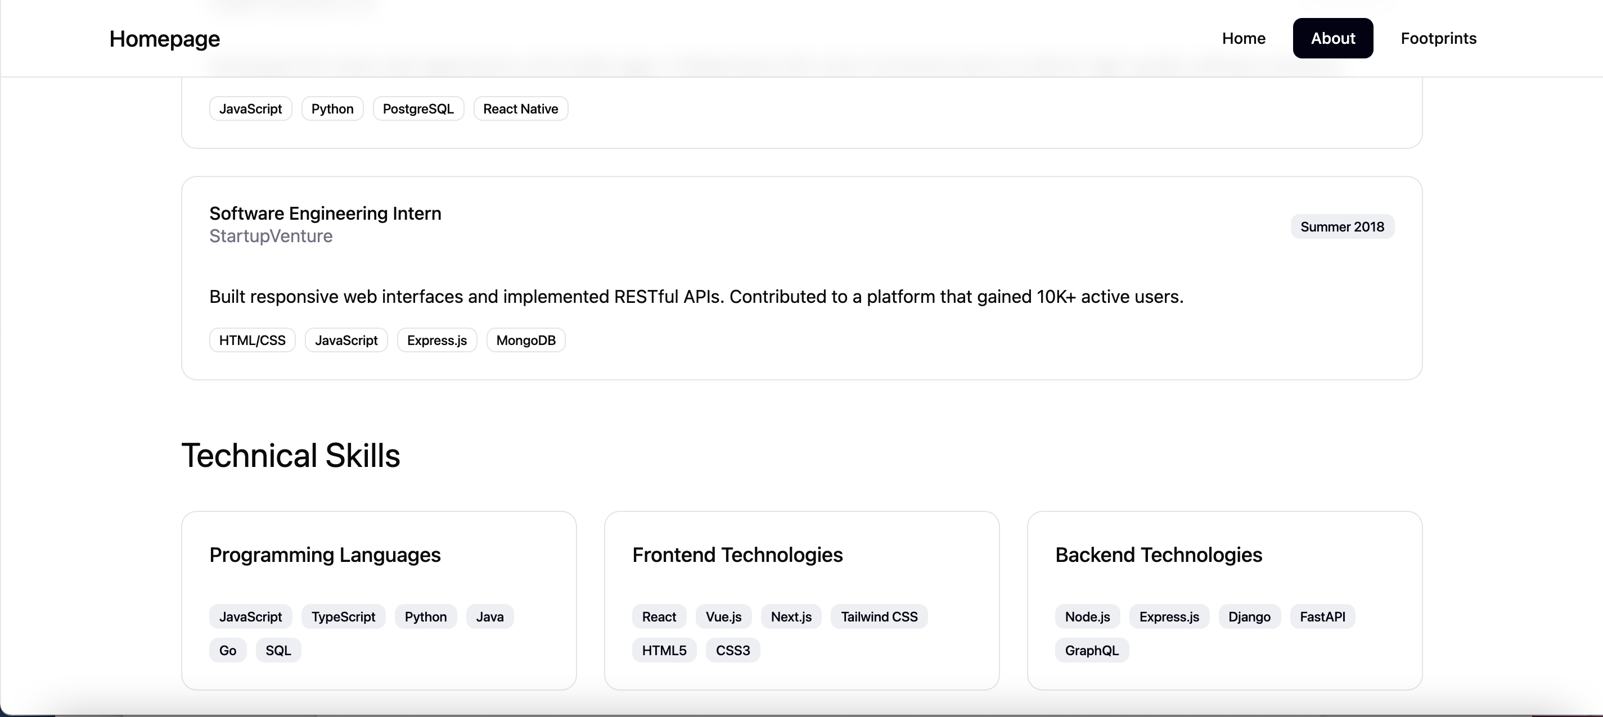

Third Page:

